

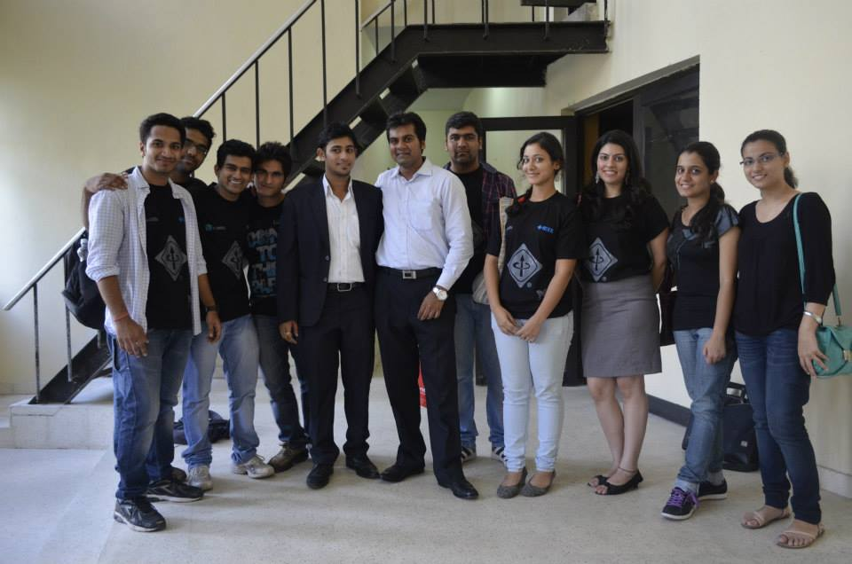

The first project undertaken was **Chakravyuh 2013: The hunt for India’s Best Security Expert**, powered by Information Security Council of India and Kyrion Securities Pvt. Ltd. This is an Information Security event that featured the final competition Chakravyuh along with various **ethical hacking workshops Loophole and Xploit),** and the conference with elite speakers and delegates. The national level event witnessed massive participation in both online and onsite events. The team worked hard in making the event a success. Their diligence and perseverance paved the way for this event to reach fruition. From the work of hospitality managers to calling people for their confirmation, preparing databases, food department, publicity, logistics and everything that an organizing event demands was very well accomplished.

Mahika Bhasin